Step1. Insert the three connecters into AC power system. (Two connecters
into DC power system)
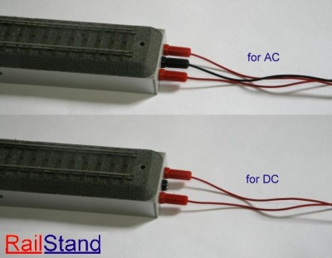

Step2. Release all of 16 hand screws.
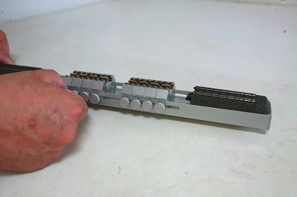Step 2: If need you can adjust the moveable track for your locomotive
need.
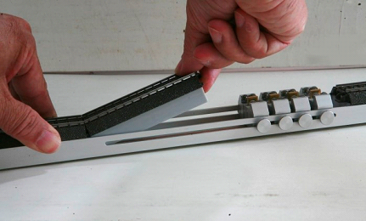

Step3. Pre-adjust 8 bearing sets position close to the locomotive dynamic
wheels.
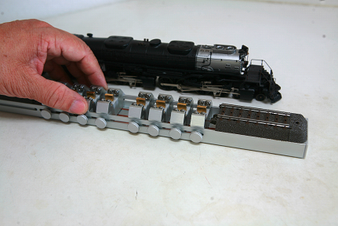
Step4. Put the locomotive on the roller test stand and adjust the bearing
sets to ensure each wheel is right position between two bearings.
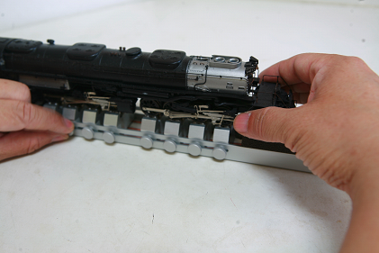

Step5. Turn on the power and drive the locomotive run.
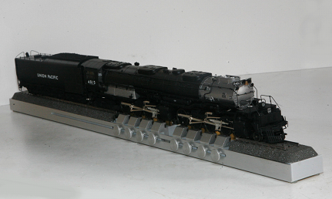
Step6. Run the locomotive for a while then screw up the hand-screws gently (Please do not screw the hand-screw too tie) or do nothing because we using the principle of gravity to conduct electricity
